
Iqra University
Islamabad Campus
Mid-Term Examination- Fall 2025 Semester
Course Code: CSC 337 | Course Title: Web Programming Languages
Teacher’s Name: Faheem Shaukat | Total Marks: 25
Date & Time: 06-May-2025 (08:30AM to 10:00AM) | Total Time: 90 Minutes
Student’s Name: | Registration No:
Students are advised to read and follow these instructions:
- Write your Registration Number, other relevant information on the front page of the answer booklet & sign it in the appropriate space.
- Point out any discrepancy (torn pages, loose sheets etc.) to the invigilating staff.
- Do not share/borrow stationery items and calculator.
- Manage your time according to the marks allotted to the respective questions.
- Please ensure that the area in your threshold is clean. You will be charged for any material which can be classified as ‘helping in the paper’ found near you.
- Ask for clarifications by the Course Instructor only within the first 15 minutes of the start of the paper.
- Mobile phones are not allowed in the Examination Hall.
- The marks for each question are written in parentheses ( ).
- Don't write any thing on the Admit Card.
Q. No. 1 Differentiate between the provided Bootstrap navigation/components and justify their use-cases based on web standards and component behavior: CLO-1 [5 Marks]
- Tabs vs Pills
- Pagination vs Breadcrumb
Include the main Bootstrap classes used for each and their typical appearance or behavior.

Component | Purpose | Key Class | Active State
Tabs | Switch content sections | .nav-tabs | Only one
Pills | Horizontal menu | .nav-pills | Multiple possible
Pagination | Navigate numbered pages | .pagination | One page active
Breadcrumb | Show site path/hierarchy | .breadcrumb | Last item active
Q. No. 2 Construct a feedback form using only HTML (no CSS frameworks allowed) to replicate the given layout. Provide the complete HTML code that produces the required webpage. CLO-2 [7.5 Marks]

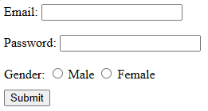
<!DOCTYPE html>
<html>
<body>

<form>

<label>Email:</label>
<input type="email" name="email">
<br><br>

<label>Password:</label>
<input type="password" name="password">
<br><br>

<label>Gender:</label>
<input type="radio" name="gender" value="male"> Male
<input type="radio" name="gender" value="female"> Female
<br><br>

<input type="submit" value="Submit">

</form>

</body>
</html>
Q No.3 Implement the given table layout using HTML and Bootstrap so that it appears exactly as shown. Provide the complete and functional code. CLO2 (7.5 Marks)
Firstname | Lastname | Email
Asad | Ameen | asad@yahoo.com
Numan | Ahmed | numan@yahoo.com
Muhammad | Zahed | mzahed@yahoo.com

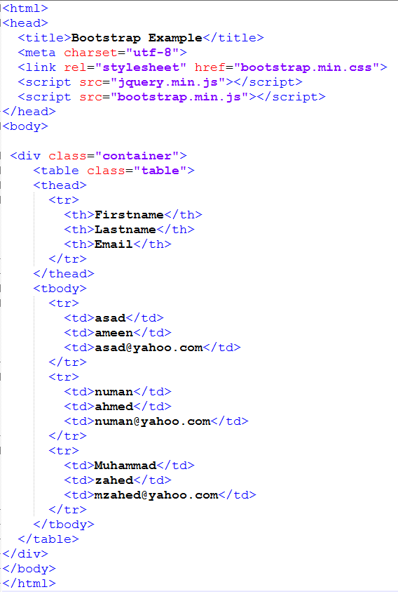

Q. No. 4 Analyze the provided CSS stylesheet and HTML structure to determine how multiple styles combine and identify the final styles applied to each HTML element. CLO-3(5 Marks)
*{  font-size: 50px;  font-family: Arial;  }  h1,h3{  color: green;  font-style: normal;  }  p.note{  font-size: 40px;  font-style: normal;  border-style: dotted;  }  ul>h2{  font-family: 'Courier New';  font-size: 40px;  color: blue;  font-style: italic;  }  div h3{  font-family: Calibri;  color: red;  font-style: italic;  }  div+h1{  border-style: dotted;  color: navy;  } | <body>  <div> Paragraph 1 </div>  <br/>  <div>  <h3> Paragraph 2 </h3>  <h2> Paragraph 3 </h2>  </div>  <h3> Paragraph 4 </h3>  <div>  <ul>  <li> Paragraph 5 </li>  </ul>  <h2> Paragraph 6 </h2>  </div>  <h1> Paragraph 7 </h1>  <p class="note"> Paragraph 8 </p>  </body>
Considering both CSS and HTML, mention the CSS properties in following table that will be applied on elements in sequence. (Mention NIL if no style is applied on element).

 | Font Size | Font Family | Font Style | Border Style | Text Color
Paragraph1
Paragraph2
Paragraph3
Paragraph4
Paragraph5

Paragraph | Font Size | Font Family | Font Style | Border Style | Text Color
Paragraph 1 | 50px | Arial | normal | NIL | NIL
Paragraph 2 | 50px | Calibri | italic | NIL | red
Paragraph 3 | 50px | Arial | normal | NIL | NIL
Paragraph 4 | 50px | Arial | normal | NIL | green
Paragraph 5 | 50px | Arial | normal | NIL | NIL

